‘’

[Date]

Team LOCALHOST

Agile systems

AR-VR PAAS

PaaS

**Project Title: AR – VR PaaS**

**Group Name: LOCALHOST**

**Group Members:**

|  |  |  |
| --- | --- | --- |
| **NAME** | **SAP ID** | **ROLL NO.** |
| **Aditya Kumar** | **500066319** | **04** |
| **Anuj Verma** | **500066910** | **09** |
| **Dhananjai Kalra** | **500070904** | **14** |
| **Mayank Joshi** | **500070105** | **25** |

Contents

1. ABSTRACT 3
2. Introduction 4
   1. Manifestos for Agile Software Development 5
3. Methodology 6
4. Objective and Aim 7
5. Requirements (as for now) 7

6. Data flow Diagrams 8

# ABSTRACT

AR and VR technologies use high amount of graphics and processing in order to work, which ultimately require high performance machines that are quite expensive. So if a person wants to utilize this technology, they will have to shell out a significant amount of money just on the machine itself which is not very cost effective. As rapid technological changes have become a general scenario today, purchasing such machines which support AR-VR can be categorized into a bad and obsolete investment.

The best example for the above mentioned problem can be taken of a freelance developer. A freelance developer may have a project that requires the use of AR or VR once in a while. Also for one project he may require a comparatively simpler machine and for other he may require a whole set of advanced configurations. Thus, making the job of acquiring and updation expensive as well as tedious. In such scenario, upgrading his machine will constantly require to stress out a lot of money which may lead to financial troubles. Also these machines are not exactly user friendly when it comes to carrying them or in their maneuverability. Therefore the best possible way to counter such limitations is to bring the facility of AR-VR to users with the help of online platforms. They are cheap, easily accessible and can bend to the users will. They can provide the same facilities to all users on any device using cloud services.

Another example can be taken for a university where they will be requiring machines for every student that opts for a course that uses AR or VR technology based learning/creation. To fulfil those needs they will have to constantly upgrade their hardware as per the needs and all the hardware will also be requiring maintenance which leads to high costs.

Our product aims to provide AR-VR Platforms Asa Service where people/organizations will be able to use our cloud platform as per their requirements. Our platform will give them capabilities to render anything and everything on cloud using our servers. All the services provided will use basic configuration machines and generate high quality content which otherwise would not be possible with a low end system.

This platform will be used on commercial basis. Users will be able to get access to our service on pay per day basis or a long term plan. Our platform will also provide the feature/capability of scalability which will allow them to upgrade or downgrade their cloud machine capabilities/performance as per their current needs allowing them to pay only for what they use rather than paying for a high performance machine all at once which may or may not be of their later on.

# Introduction

The field of software development and management has significantly grown in the past ten years. At a point in time, the basic need of common populous was to just sort out their grocery lists but today, software in itself have become a major part of everyone’s day to day life. Innovations and changes in computer software are a very common occurrence in this time. This is all because the users around the globe today, are driven by the zeal of living life virtually than in reality. As such, the concept of **augmented reality** and **virtual reality** has become a booming market today.

This project is based on latest and emerging technologies of **Augmented Reality and Virtual Reality**. The main purpose of AR-VR is to provide consumers with a sense of living a limitless virtual life, which is free of any obligations. Following this idea and principles and values of agile manifestos, we are developing a **Platform as a Service** for the users who want to create their own Augmented Reality and Virtual Reality content. The services provided in this platform will target every user on any device, unbiased towards the hardware requirement. The main idea is to generalize AR-VR creation to all the users that need it, without constructing any hardware limitations.

Even though this technology itself is not complex in nature, the use of AR-VR is confined to a small group of people. This limitation is as such because of the high configuration it demands from the hardware and network. The maneuverability of this technology highly depends upon the hardware and software it is running on.

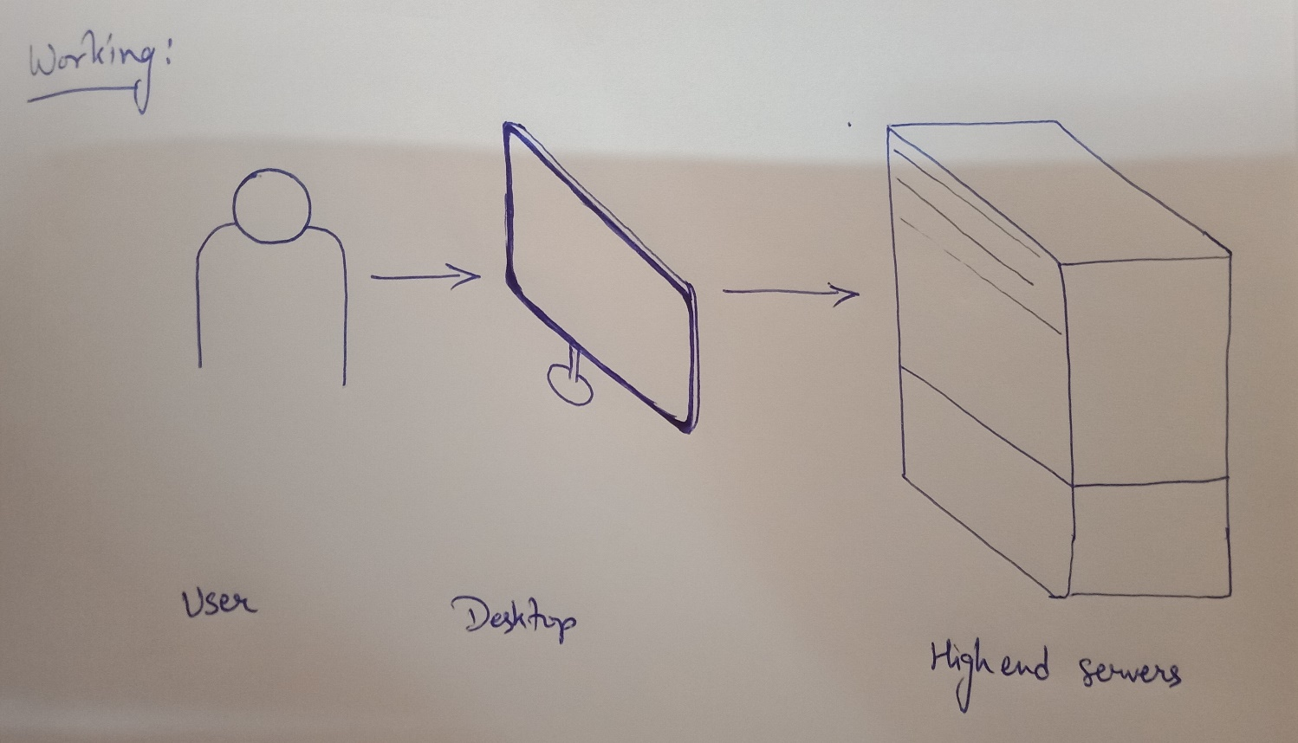

Our platform will eliminate this limitation to the best possible extent and provide users with the same services, unbiased towards the network or hardware they are using. Creation, modification, save and download are the four main services we will provide on this platform. The service will fulfill all the needs of the user in generating AR and VR content. The software will run on our servers and an instance of the process will be displayed on the user’s desktop.

Additional services provided on this platform might also include a marketplace for selling and buying the AR and VR content, creating a community in itself. We aim to create this platform very user friendly, so that users can access, modify and create whatever they want without restrictions. All of the processes, from creation to modification, will be contemplated in real time. The users will also be given services to save and download their content on their systems or on the cloud for further alterations.

Concerning the financial factors, this platform will be made accessible to consumers on a subscription basis only. The platform will be developed exactly according to the needs of the customers.

## Manifestos for Agile Software Development

The agile manifestos include four of the most important values for development, regulating customer satisfaction as well as ensuring flexibility towards changes throughout. Our software follows all the values and principles as per listed under agile manifestos and ensures optimal quality of service towards the customers whilst non-compromising the integrity of the developer as well as the software.

* + - **Individuals and interactions** over processes and tools: The AR-VR PaaS strictly follows one agenda, i.e. providing AR-VR services to every consumer without biasness towards hardware. All the processes and tools used in the development are regulated optimally, keeping in mind the needs of the consumer base.
    - **Working software** over comprehensive documentation: Practicality is one of the foremost module of this project. Providing consumers with a service to model their imagination is our main goal. Agile manifestos lean towards working software more than documentation. Even though documentation is a tedious task, we strive in creating a balance between every phase of development. From documentation to the working model each and every task is taken care optimally without hindering the other.
    - **Customer collaboration** over contract negotiation: Customer collaboration is a must in developing the most efficient software. Our platform will directly interact with the consumers at every point of working and keep them updated on development of the product, as well as the working of every phase.
    - **Responding to change** over following a plan: A customer is very prone to change his/her ideas in the midst of development phase. Our platform supports as well as encourages the consumers to flow their ideas freely. The development will always be in close collaboration with the consumer and will always be flexible towards changes.

# Methodology

We are using FDD (Feature Driven Development) methodology to develop our project as it is the best fit to develop project with multiple features, following this methodology will allow us to add new features into existing project thus making it more feature rich and increasing its functionalities over time. FDD is a combination of iterative and incremental software development process. The development under FDD is carried out on client valued functionality and client’s perspective.

Development under FDD initiates with a deep understanding of the scope and context of the system and detailed models are created at each level for peer review and all the models are progressively merged into an overall wholesome model.

**Phase 1 : Building Features List**

* Pre-made drag and drop packages of various items and objects that can be used to create new content
* User can create his/her things/object for their content
* Clicking pictures from various angles and render it into VR image
* Access to the service on low end devices
* Generate and display AR-VR content in real time (processing done on the servers)
* Marketplace to trade content and generate revenue

# Objective and Aim

* This platform can provide development of AR and VR content such as videos, photos and applications
* This platform can also work as a marketplace for users to create and sell their AR and VR content
* Provide the service to people who cannot afford high performance hardware (by giving them subscription service to our platform)
* Provide service to institutions and organizations for mass use at low cost.

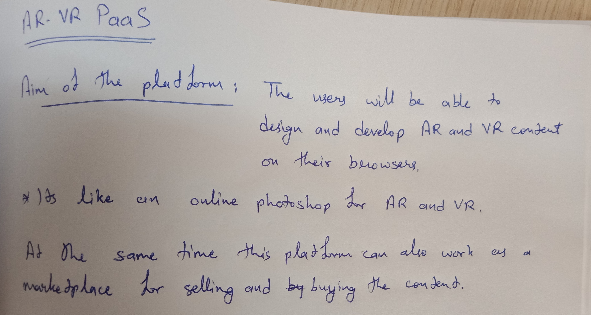

# Requirements (as for now)

* Server Side

1. Cloud Infrastructure (High performance)

2. Internet connectivity (Low latency, high speed fiber optic/5G)

3. Website as a web platform (API also)

* Rapid Application Development methodology of software development

(Server preferences: AWS, Photon Engine)

* User end

1. Computer with basic GPU

2. Internet connectivity (high speed fiber optic/5G with low latency)

3. VR headset (for VR content)

4. Smartphone Application (if used on smartphone)

# 6. Data flow Diagrams

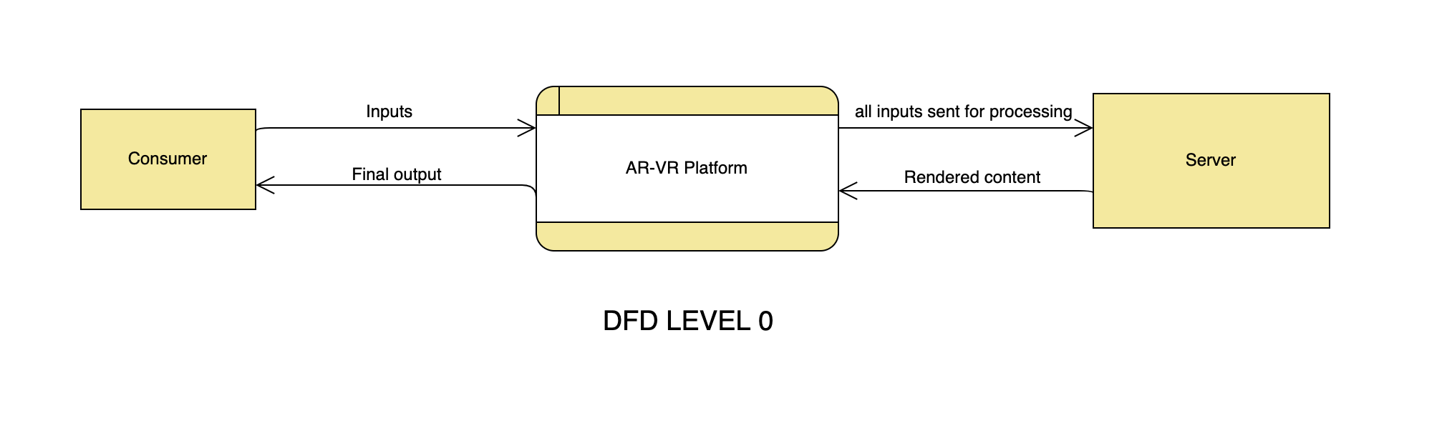

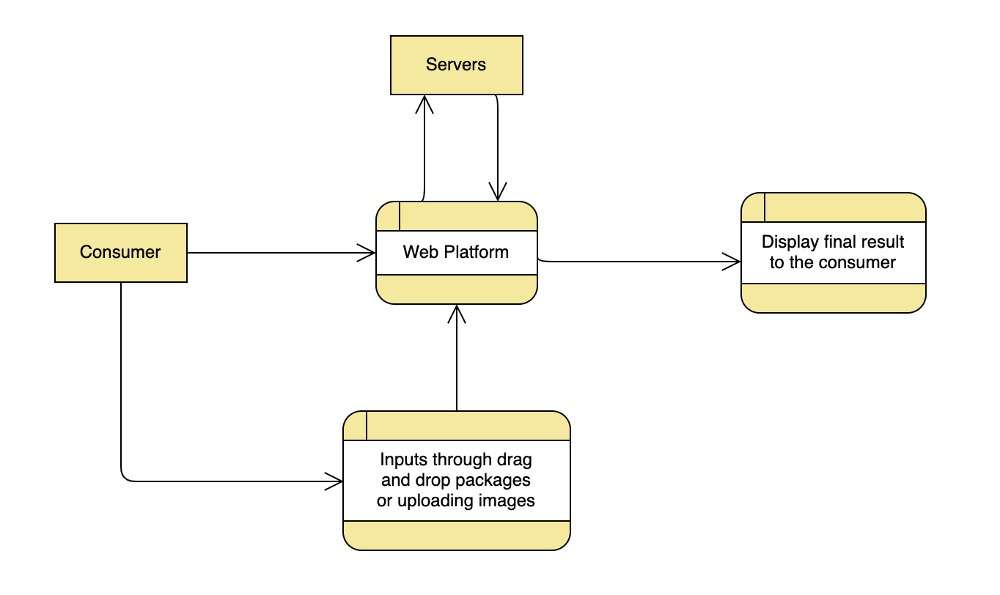

**DFD LEVEL 1**

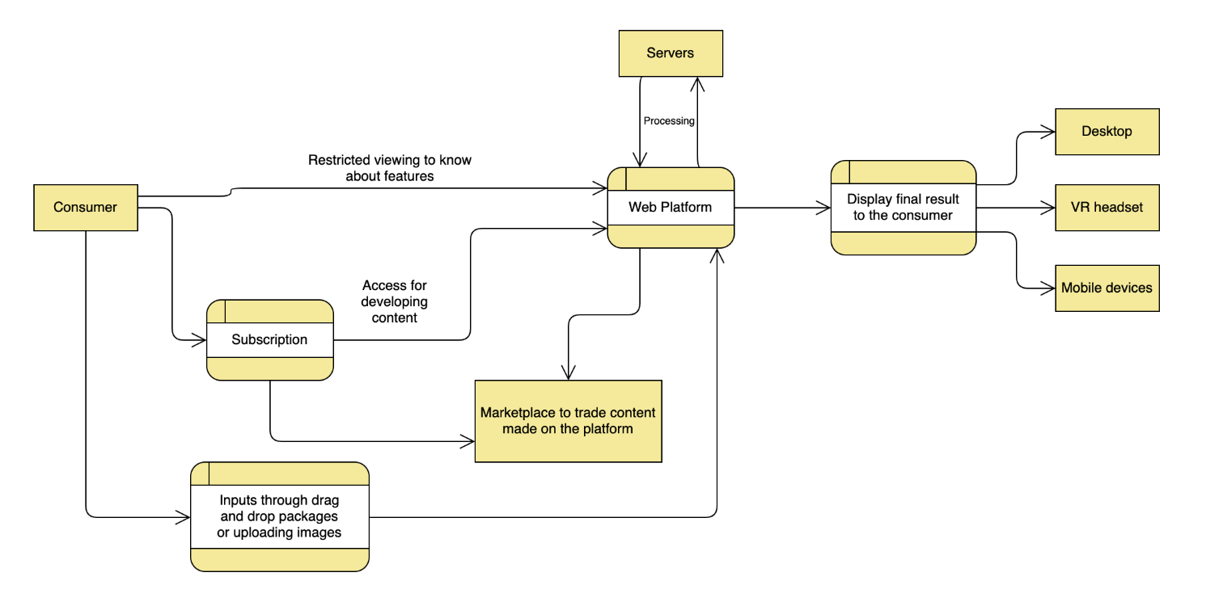

**DFD LEVEL 2**